Press release Sulz am Neckar, Germany, August 2016

Antibacterial plastic

MEDI grip products for the most demanding hygiene requirements

HEINRICH KIPP WERK is producing antibacterial products for the first time. The material, which has been enriched with micro silver, permanently reduces bacterial growth on the surface and therefore minimises the risk of infection. The operating parts are used in medical or food-production areas, as well as in rehabilitation and care facilities.

The new MEDI grip product line is based on plastic which has been enriched with micro silver. Because the material contains silver particles all the way through and not just on the surface, the operating parts retain their full antibacterial effects even when there is slight wear and tear. This has been confirmed at an accredited test laboratory by multiple ASTM E-2180 tests.

MEDI grip products effectively combat multi-resistant microbes such as MRSA and are therefore used extensively in places with the strictest hygiene requirements. Between cleaning cycles, the number of microbes present is continually reduced, which significantly minimises the risk of infection arising from contact. The operating parts are resistant to moisture and numerous cleaning agents, and they do not have any toxic side effects. Areas of application include laboratories, hospitals, research institutes, rehabilitation or care facilities, and food-production plants.

KIPP now offers a selection of grips in the antibacterial MEDI grip design. All operating parts have the characteristic KIPP design and ergonomic form.

Characters including spaces:
Headline: 62 characters
Pre-head: 21 characters
Text: 1451 characters
Total: 1534 characters

HEINRICH KIPP WERK KG
Stefanie Beck, Marketing
Heubergstrasse 2
72172 Sulz am Neckar, Germany

Telephone: +49 (0) 7454 793-30
E-mail: stefanie.beck@kipp.com

Additional information and press photos
See www.kipp.com, Region: Germany, Category: News / Press area

Photo
KIPP MEDI grip products for the most demanding hygiene requirements
Photo: KIPP

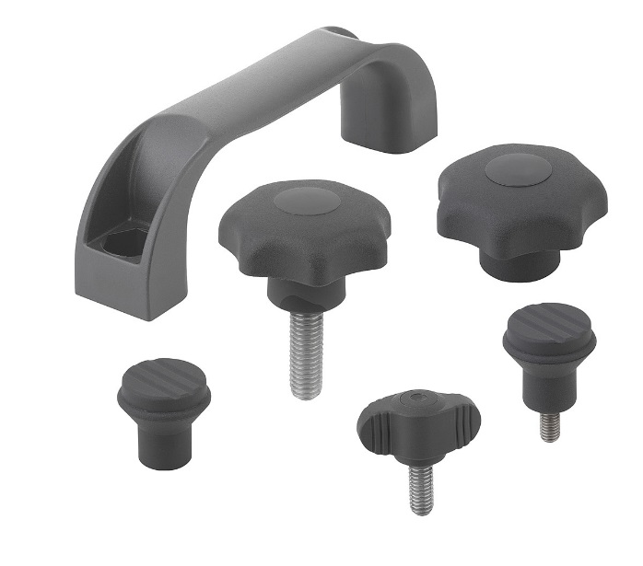 | Image file:  KIPP-MEDI grip.jpg

Image copyright: Released for licence-free and royalty-free publication in speciality media.
Please cite the source and submit a reference.

