Press release Sulz am Neckar, Germany, July 2015

Practical handling

KIPP expands its product range to include aluminium mounting brackets

HEINRICH KIPP WERK is expanding its product range to include practical mounting brackets made of lightweight aluminium. The mounting brackets ensure a secure hold, can be used in a many different of applications and can be combined with other KIPP products.

The new mounting brackets from KIPP are a user-friendly assembly aid for many products, including indexing plungers, cam-action indexing plungers and spring plungers. The wide variety of different standard or fine threads guarantees that components can be suitably attached. What's more, the clamping slots fix the component in place when screwing it to the mounting bracket, which makes it easier to use. The mounting brackets can be combined with many KIPP operating parts. Lightweight aluminium and the compact design make assembly easier even where space is limited.

KIPP supplies the mounting brackets in two variations: in Form A the fastening hole runs parallel to the thread whereas in Form B the hole runs perpendicular to the thread. The mounting bracket is attached to the corresponding boreholes with ISO 4762 socket head screws. All mounting brackets are matt black anodized and are supplied ex works with standard or fine threads from M6 to M20 x 1.5.

Characters including spaces:
Headline: 69 characters
Pre-head: 18 characters
Text: 1223 characters
Total: 1310 characters

HEINRICH KIPP WERK KG
Stefanie Beck, Marketing
Heubergstrasse 2
72172 Sulz am Neckar, Germany

Telephone: +49(0)7454 793-30
e-mail: s.beck@kipp.com

Additional information and press photos
See www.kipp.com, Region: Germany, Category: News/Newsroom

Photos

Image text:
KIPP mounting brackets made of lightweight aluminium can be used in many different applications and can be combined with other KIPP products.

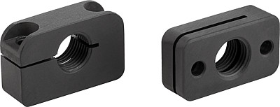  Image copyright: Released for licence and royalty-free publication in speciality media.  Please cite the source and submit a reference. | Image file:  KIPP Haltestücke Aluminium.jpg

